**A**

**Report**

**On**

**Students Seminar**

**(17th January, 2023)**

**Department of Defence Studies**

**Rabindra Mahavidyalaya,Champadanga**

**Theme: *WAR EFFECTS ON PRESENT SCENARIO***

**Venue: Room No. 67 (Department of Defence Studies)**

**Date: 17th January, 2023**

**Organizer: Department of Defence Studies**

**Category of the Seminar: Departmental**

**Paper Presenters: Students of Semester – I, III, V (General)**

**Total No. of Participants: 55 Students (Including paper presenters)**

**Objective**:

* To gain knowledge about war
* To provide an opportunity for participants to gain knowledge and skill through lectures, discussion and interactive activities.
* To provide a comprehensive overview of a particular topic
* To provide in depth training on a specific subject.
* To grow presentation skills.

**Highlights**: A Departmental Seminar was organized on 17th January, 2023 by the Department of Defence Studies. The Seminar held in the Department of Defence Studies room no. 67. Fifty five participants attends in the seminar. prof. Dipankar Jana hosted the seminar and he welcomed all participants. In his inaugural speech he discussed the necessities to know why a country (India) avoid war. All technical session were chaired by the departmental faculty. Prof.Dipankar Jana acts as judge and Prof. Srikanta Adhikari monitored the whole session. All the sessions were very interactive where pupils have been quite enthusiastic and all of their questions have been sitisfactoryily answered. Finally, the seminar ends with a grand success and vote of thanks was given by Prof.Srikanta Adhikari .

The Department would also take the opportunity to convey its thanks to the college administration for their support.

Additionally, a manual feedback form was created and circulated to the students guardians for their valuable feedback. The feedback received was extremely positive.

**Outcome of the Seminar**:

**This topic is included in the CBCS syllabus as well as in the previous 3years degree course. All the participants including students are also benefitted through getting an overall idea in the discussion. Many of the courageous participants express their expectation for arranging more seminars in future.**

**STUDENT’S SEMINAR**

***Theme: WAR EFFECTS ON PRESENT SCENARIO***

**Date: 17th January, 2023**

**Venue: Department of Defence Studies, Rabindra Mahavidyalaya,Champadanga**

**Time: 12:00 to 03:00 pm**

* **Inauguration**
* **Principal’s speech**
* **Technical session-1: 12:30 to 1:15 pm**
* **Chairman: Dipankar Jana**
* **Rapporteur: Srikanta Adhikari**
* **Paper: War Effects on Present Scenario in India**
* **Paper: Principles of War and Present Scenario**
* **Technical Session-2: 1:30 to 2:30 pm**
* **Chairman: Srikanta Adhikari**
* **Rapporteur: Dipankar Jana**
* **Paper: War Effects and internal Security**
* **Paper: Nuclear War Effects**
* **Prize distribution**
* **Vote of Thanks: Srikanta Adhikari**

**STUDENT’S SEMINAR**

***Theme: WAR EFFECTS ON PRESENT SCENARIO***

**Date: 17th January, 2023**

**Venue: Department of Defence Studies, Rabindra Mahavidyalaya,Champadanga**

**Time: 12:00 to 03:00 pm**

* **Paper: War Effects on Present Scenario in India**
* **Presenters: Ranit Sadhukhan, Prity Ghosh, Mousumi Ghosh.**
* **Paper: Principles of War and Present Scenario**
* **Presenters: Shovona Laha, Aditya Das, Dipak Sil.**
* **Paper: War Effects and internal Security**
* **Presenters: Keya Belel, Bristi Manna, Deba Hambir.**
* **Paper: Nuclear War Effects**
* **Presenters: Md Imran, Koushik Samanta, Parul Mistry**

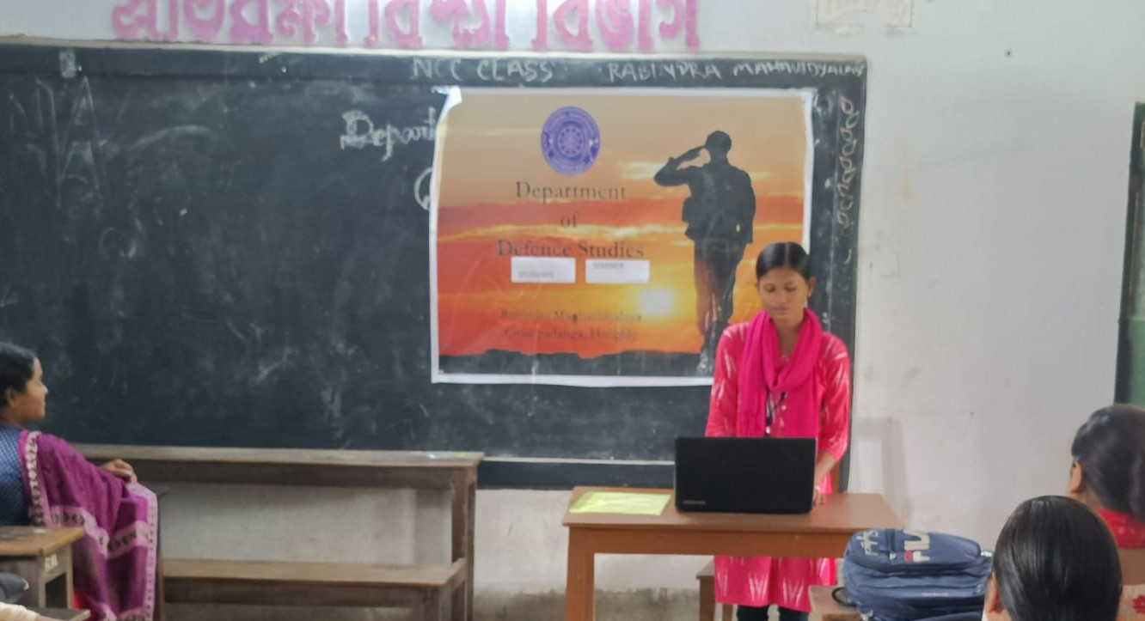

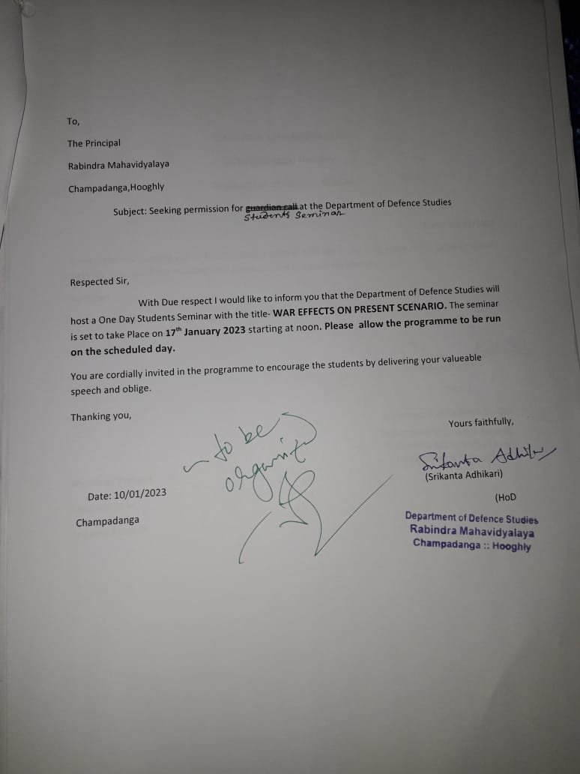

**FEEDBACK ANALYSIS**

**RESPONDENTS (STUDENTS)**

|  |
| --- |
|  |
|  |
|  |
|  |
|  |
|  |

**ACTION TAKEN REPORT**

**Name of the Program: Students Seminars**

**Duration: 17th January, 2023**

|  |  |
| --- | --- |
| **FEEDBACK RECEIVED** | **ACTION TEKEN** |
| Teachers as well as students gave positive feedback. Most of them were of them were happy and satisfied with the event. | It was decided that this event will be continued in future as well. |